**Project Design Phase-I**

**Solution Architecture**

| Date | 24 May 2023 |
| --- | --- |
| Team ID | NM2023TMID07188 |
| Project Name | Journey to Sustainability: Decoding the CO2 Impact of Travel |

**Solution Architecture:**

The solution architecture for addressing the CO2 impact of travel can involve various components and technologies. Here's a high-level overview of a potential solution architecture.The Goals are to:

* Data Collection and Integration.
* Green Travel Certification
* Carbon Offset Integration
* User-Facing Platform.
* Collaboration and Communication.

**Decoding the CO2 Impact of Travel - Solution Architecture Diagram:**

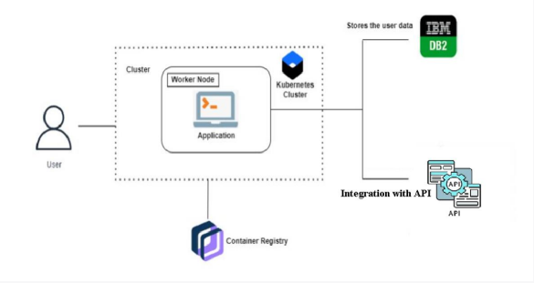

*Figure 1: Architecture and data flow of the Decoding the CO2 Impact of Travel application*